TITLE ARTICLE ( capital letter , Arial 12 PT, bold, No more from 12 say)
( One line spacing blank , 12 point font)

Writer First 1) , Writer Second 2) , And Writer Third 3) (Arial 12 PT, bold)
( One line space blank , 12 point font)

1 Department , Institution (Arial 12 pt)
2 Departments , Institutions
3 Majors , Institution
E-mail: correspondence@mail.com (Arial 12 pt)
(One line space blank, 12 point font)

Abstract (Arial 10 pt, bold, no more (from 200 words)
(One line space blank, 10 point font)

The abstract should be written in English. The abstract is written with Arial font size 10 and single spacing. The abstract should summarize the paper's content , including problems, the aim of the research, the research method, the results, and the conclusions of the paper. It should not contain any references or displayed equations. The abstract should be no more than 200 words.
(One line space blank, 10 point font)
Keywords: up to 5 keywords in English (Arial 10 pt, italics)
(two line space empty , 10 points font)

INTRODUCTION (Arial, 12pt, bold, 12pt Line Spacing before-after)
Template This used as guidelines writing article Olympic Accountancy Vocational (OAV) IX year 2026. Article must load Introduction , Method Study , Results And Discussion , Conclusion And Suggestion, as well as List Library . Article written in English​ use type letter Arial, font size 12, spacing 1.5, left and right justified , left – right – top – bottom margins each 3 cm, using paper A4 size (210 mm x 297 mm). Script minimum consists of from 3000 say And maximum 5000 say No including title , abstract , reference and attachments .
Part introduction includes : background behind , formulation problem or question study , And objective study . Writing parts from introduction This without use sub chapter /subchapter title . Source reference originate from primary sources ( journals ) published in the last 5 years last . Source reference Which listed in beginning sentence written use system Name ( year ), whereas when listed in end sentence use system (Name, year ). Quote direct more from 3 line, written use space 1, indentation Left and right .

METHOD RESEARCH (Arial, 12pt, bold, 12pt Line Spacing before-after)
Method study at least to describe approach Which used in study , population And sample study , explain definition operational variables along with tool data measurement or method gather data, And method data analysis .
If tool measurement data use questionnaire , so need listed results test validity And reliability instrument study .

RESULTS AND DISCUSSION (Arial, 12pt, bold, 12pt Line Spacing before-after)
How to present in the section This can carried out : 1) discussion separated from results or 2) discussion united with presentation results . The intended results is summary results data analysis , not results study in raw data form . Results of data analysis from statistical data processing software served with type repeat in customized table​ with needs , not with how to copy the output results analysis . Example data presentation in form table as Table 1.
Table 1. Table Title (Arial, 12pt, 1 line space, bold)
Respondent Code (Arial, 10pt, bold) | Age | Semester | Literacy Score Finance
R01 (Arial, 10pt) | 19 | 2 | 78
R02 | 20 | 4 | 65
R03 | 21 | 6 | 83
R04 | 22 | 8 | 74
R05 | 20 | 4 | 88

Example presentation data in form picture , chart And similar like on Figure 1.
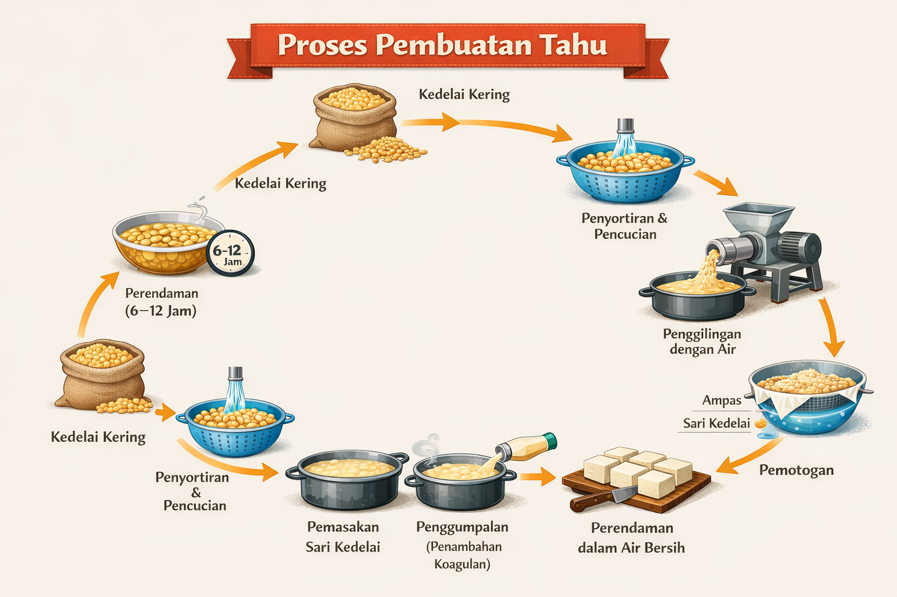
Picture 1. Process Making Tofu

CONCLUSION (Arial, 12pt, bold, 12pt Line Spacing before-after)
Conclusion is summary on findings study And the implications .
Suggestion given For development And study continued .

LIST BIBLIOGRAPHY (Arial, 12pt, bold, 12pt Line Spacing before-after)
bibliography​ is part end from paper , written in order alphabetical following APA Style ( http://www.apastyle.org/ ). The composition loading : author's name , year publication , title of paper or textbook, name of journal or publisher , And page . Following This a number of example method writing list library according to WHAT Style. Recommended use application Mendeley .

Reference List: Author/Authors

One Author
Suwardjono . (2018). Accounting Theory : Engineering reporting Finance ( Edition 3). BPFE.

Two Authors
Dechow, P. M., & Skinner, D. J. (2000). Earnings management: Reconciling the views of accounting academics, practitioners, and regulators. Accounting Horizons, 14(2), 235–250.
Hery, & Widyawati , D. (2020). Accounting finance medium . Grasindo .

Three to Seven Authors
Healy, P. M., Hutton, A. P., & Palepu, K. G. (1999). Stock performance and intermediation changes surrounding sustained increases in disclosure. Contemporary Accounting Research, 16(3), 485–520.
Weygandt, J. J., Kimmel, P. D., & Kieso , D. E. (2020). Financial accounting (11th ed.). Wiley.

More Than Seven Authors
Bushman, R.M., Piotroski, JD, Smith, A.J., Chen, Q., Cheng, Q., Dhaliwal, D., . . . Zhang, X. (2004). Financial reporting incentives for conservative accounting: The influence of legal and political institutions. Journal of Accounting and Economics, 38(1–3), 1–37.

Organization US Author.
International Accounting Standards Board. (2018). Conceptual framework for financial reporting. IFRS Foundation.

Unknown Author
Dictionary of accounting terms (3rd ed.). (2015). McGraw-Hill Education.

Two or More Works by the Same Author
Watts, R.L. (2003). Conservatism in accounting: Part I—Explanations and implications. Accounting Horizons, 17(3), 207–221.
Watts, R.L. (2003). Conservatism in accounting: Part II—Evidence and research opportunities. Accounting Horizons, 17(4), 287–301.
Watts, R.L., & Zimmerman, J.L. (1986). Positive accounting theory. Prentice Hall..

Two or More Works by the Same Author in the Same Year
Scott, W.R. (2015a). Financial accounting theory (7th ed.). Pearson.
Scott, W.R. (2015b). The information perspective in financial accounting. Accounting Perspectives, 14(2), 79–101.

Introductions, Prefaces, Forewords, and Afterwords
Kieso , D. E., & Weygandt, J. J. (2020). Introduction. In DE Kieso , JJ Weygandt, & TD Warfield (Eds.), Intermediate accounting (17th ed., pp. 1–25). Wiley.

Reference List: Articles in Periodicals

Article in Journal Paginated by Volume
Ball, R., & Brown, P. (1968). An empirical evaluation of accounting income numbers. Journal of Accounting Research, 6, 159–178.

Article in Journal Paginated by Issue
Jensen, M. C. (2001). Value maximization and the corporate objective function. Journal of Applied Corporate Finance, 14(3), 8–21.

Article in a Magazine
Byrnes, N. (2002, July 22). The new transparency in corporate reporting. BusinessWeek, 3790, 45–48.

Article in a Newspaper
Sorkin, A. R. (2020, March 15). Corporate accounting faces scrutiny amid crisis. The New York Times, B1–B2.

Reference List: Books

Edited Book, No Author
Graham, J.R., & Harvey, C.R. (Eds.). (2001). Corporate financial reporting practices. Elsevier.

Edited Book with an Author or Authors
Brigham, E.F. (2019). Financial management: Theory and practice (15th ed.). Cengage Learning.

A Translation
Pacioli, L. (1994). Summa de arithmetica (A. Clarke, Trans.). Oxford University Press. (Original work published 1494)

Edition Other Than the First
Harrison, W.T., Horngren, C.T., & Thomas, C.W. (2018). Financial accounting (11th ed.). Pearson.

Article or Chapter in an Edited Book
Healy, P. M., & Palepu, K. G. (2001). Information asymmetry, corporate disclosure, and capital markets. In J. Hand & B. Lev (Eds.), Intangible assets (pp. 33–60). Oxford University Press.

Reference List: Other Print Sources

Entry in an Encyclopedia
Bromwich, M. (2015). Management accounting. In C. Cooper (Ed.), Wiley encyclopedia of management (3rd ed., pp. 1–5). Wiley.

Dissertation Abstract
Sari, DP (2021). Corporate governance and earnings quality in ASEAN countries (Doctoral dissertation, University of Indonesia). Dissertation Abstracts International, 82, 1123A.

Government Document
Ministry of Finance of the Republic of Indonesia. (2022). Report finance government center 2021. Ministry of Finance of the Republic of Indonesia.

Report from a Private Organization
Bond Indonesian Accountants . (2022). Standards accountancy finance effective 2022. IAI.

Conference Proceedings
Siregar, SV, & Utama, S. (Eds.). (2023). Proceedings of the International Conference on Accounting, Governance, and Sustainability (ICAGS 2023). Atlantis Press.
Hapsoro , D., & Rahman, A. (Eds.). (2022). Proceedings of the International Conference on Economics, Business, and Accounting Research (ICEBAR 2022). Springer. https://doi.org/10.1007/978-3-031-12345-6

Reference List: Electronic Sources (Web Publications)

Article From an Online Periodical with DOI Assigned
Francis, J., LaFond, R., Olsson, P., & Schipper, K. (2004). Costs of equity and earnings attributes. The Accounting Review, 79(4), 967–1010. https://doi.org/10.2308/accr.2004.79.4.967

Article From an On line Periodical with no DOI Assigned
Sari, DP (2020). The effect of audit committee effectiveness on earnings management. Journal Accountancy Multiparadigm , 11(2), 215–230. https://jam.ub.ac.id/index.php/jam/article/view/2020

Wijayanti, R. (2019). Corporate governance and financial distress prediction. Journal Finance and Banking , 23(3), 345–357. https://jurnal.unmer.ac.id/index.php/jkdp

Abstract
Pratama, A. (2022). The impact of ESG disclosure on firm value in ASEAN countries [Abstract]. Asian Journal of Accounting Research, 7(1), 88–89.

Newspaper Article
Sorkin, A. R. (2023, March 15). Regulators increase scrutiny on corporate financial reporting. The New York Times. https://www.nytimes.com

Electronic Books
Atrill , P., & McLaney, E. (2020). Management accounting for decision makers (9th ed.). Pearson. https://www.pearson.com
Harrison, W.T., Horngren, C.T., & Thomas, C.W. (2018). Financial accounting (11th ed.). Pearson. https://www.pearson.com

Chapter in Online Book
Healy, P. M., & Palepu, K. G. (2001). Information asymmetry, corporate disclosure, and capital markets. In J. Hand & B. Lev (Eds.), Intangible assets (pp. 33–60). Oxford University Press. https://doi.org/10.1093/019511099X.003.0002

Online Book Reviews
Zeff, S.A. (2021, April 10). Rethinking financial reporting standards [Review of the book The future of financial accounting]. Accounting Today. https://www.accountingtoday.com

Dissertation/Thesis from a Database
Putri, RD (2021). Corporate governance and earnings quality in emerging markets (Doctoral dissertation). ProQuest Dissertations Publishing. (UMI No. 1234567)

On line Encyclopedias and Dictionaries
Accounting conservatism. (nd). In Encyclopædia Britannica Online. https://www.britannica.com

On line Bibliographies and Annotated Bibliographies
International Federation of Accountants. (2022). Sustainability reporting: Annotated bibliography. https://www.ifac.org

Data Sets
World Bank. (2023). World development indicators [Data set]. https://data.worldbank.org

Graphic Data
International Monetary Fund. (2023). Global financial stability indicators [Data visualization]. https://www.imf.org

On line Interviews
Butler, C. (Interviewer) & Siregar, SV (Interviewee). (2022). The future of ESG reporting in Indonesia [Interview transcript]. https://www.accountingconference.org/interviews

On line Lecture Notes / Slides
Hapsoro , D. (2023). Earnings management and audit quality [PowerPoint slides]. https://www.university.ac.id/akuntansi

Nonperiodical Web Document / Report
International Federation of Accountants. (2023). Global accounting profession report 2023. https://www.ifac.org

Computer Software
StataCorp . (2022). Stata statistical software: Release 17 [Computer software]. StataCorp LLC.
IBM Corp. (2021). IBM SPSS statistics for Windows (Version 27) [Computer software]. IBM Corp.

E-mail
E-mails are not included in the list of references, even if you parenthetically cite them in your main text: (E. Robbins, personal communication, January 4, 2001).

On line Forum Post
Public Accountant . (2023, July 10). Challenges in implementing PSAK 71 [Online forum post]. https://www.akuntansiforum.com

Blog Post
Deloitte Indonesia. (2023, May 2). ESG reporting trends in Southeast Asia [Blog post]. https://www2.deloitte.com

Wikipedia
Sustainability accounting. (nd). In Wikipedia. https://en.wikipedia.org/wiki/Sustainability_accounting

Podcast
International Federation of Accountants. (2023, June 5). The future of global audit standards [Audio podcast episode]. https://www.ifac.org

Video Podcasts
Scott, D. (Producer). (2007, January 5). The community college classroom [Episode 7]. Adventures in Education . Podcast retrieved from http://www.adveeducation.com

Reference List: Other Non-Print Sources

Interviews, E-mail, and Other Personal Communication
No personal communication is included in your reference list; instead, parenthetically cite the communicators name, the fact that it was personal communication, and the date of the communication in your play text only.

(E. Robbins, personal communication, January 4, 2001).
A. P. Smith also claimed that many of her students had difficulties with WHAT style (personal communication, November 3, 2002).

Motion Picture
Smith, JD (Producer), & Lee, R. (Director). (2022). The accounting scandal: Lessons from corporate collapse [Motion picture]. United States: Financial Insight Films.

A Motion Picture or Video Tape with International or National Availability
Smith, JD (Producer), & Smithee, AF (Director). (2001). Really big disaster movie [ Motion picture]. United States: Paramount Pictures.

A Motion Picture or Video Tape with Limited Availability
Harris, M. (Producer), & Turley, MJ (Director). (2002). Writing labs: A history [Motion picture]. (Available from Purdue University Pictures, 500 Oval Drive, West Lafayette, IN 47907)

Television Broadcast or Series Episode
Producer, P. P. (Producer). (Date of broadcast or copyright). Title of broadcast [ Television broadcast or Television series ] . City of origin: Studio or distributor.

Single Episode of a Television Series
Writer, WW (Writer), & Director, DD (Director). (Date of publication). Title of episode [Television series episode]. In P. Producer (Producer), Series title . City of origin: Studio or distributor.
Wendy, SW (Writer), & Martian, IR (Director). (1986). The rising angel and the falling ape [Television series episode]. In D. Dude (Producer), Creatures and monsters . Los Angeles, CA: Belarus Studios.

Television Broadcast
Important, IM (Producer). (2023, November 1). The future of public sector accounting [Television broadcast]. Jakarta: Metro TV.

A Television Series
Wendy, SW (Writer), & Hartono, B. (Director). (2021). Creative accounting practices exposed [Television series episode]. In D. Firmansyah (Producer), Corporate investigations. Jakarta: Business Channel Indonesia.

Music Recording
Rahman, A. (2022). Double-entry system explained [Recorded by Accounting Education Band]. On Learning accounting basics [MP3]. Jakarta: EduMusic Records.

