JUDUL ARTIKEL (capital letter, Arial 12 pt, bold, tidak lebih dari 12 kata)
(satu baris spasi kosong, 12 point font)

Penulis Pertama¹⁾, Penulis Kedua²⁾, dan Penulis Ketiga³⁾ (Arial 12 pt, bold)
(satu baris spasi kosong, 12 point font)

¹Jurusan, Institusi (Arial 12 pt)
²Jurusan, Institusi
³Jurusan, Institusi
E-mail: korespondensi@mail.com (Arial 12 pt)
(satu baris spasi kosong, 12 point font)

Abstract (Arial 10 pt, bold, tidak lebih dari 200 kata)
(satu baris spasi kosong, 10 point font)

The abstract should be written in English. The abstract is written with Arial font size 10 and single spacing. The abstract should summarize the paper's content, including problems, the aim of the research, the research method, the results, and the conclusions of the paper. It should not contain any references or displayed equations. The abstract should be no more than 200 words.
(satu baris spasi kosong, 10 point font)
Keywords: up to 5 keywords in English (Arial 10 pt, italics)
(dua baris spasi kosong, 10 point font)

PENDAHULUAN (Arial, 12pt, bold, 12pt Line Spacing before-after)
Template ini digunakan sebagai pedoman penulisan artikel Olimpiade Akuntansi Vokasi (OAV) IX tahun 2026. Artikel harus memuat Pendahuluan, Metode Penelitian, Hasil dan Pembahasan, Simpulan dan Saran, serta Daftar Pustaka. Artikel ditulis dalam Bahasa Inggris menggunakan jenis huruf Arial, font size 12, spasi 1.5, rata kiri kanan, margin kiri – kanan – atas – bawah masing-masing 3 cm, menggunakan kertas ukuran A4 (210 mm x 297 mm). Naskah minimum terdiri dari 3000 kata dan maksimum 5000 kata tidak termasuk judul, abstrak, referensi dan lampiran.
Bagian pendahuluan meliputi: latar belakang, rumusan masalah atau pertanyaan penelitian, dan tujuan penelitian. Penulisan bagian-bagian dari pendahuluan ini tanpa menggunakan sub bab/sub judul. Sumber referensi berasal dari sumber-sumber primer (jurnal) terbitan 5 tahun terakhir. Sumber acuan yang dicantumkan di awal kalimat ditulis menggunakan sistem Nama (tahun), sedangkan bila dicantumkan di akhir kalimat menggunakan sistem (Nama, tahun). Kutipan langsung lebih dari 3 baris, ditulis menggunakan spasi 1, indentasi kiri-kanan.
METODE PENELITIAN (Arial, 12pt, bold, 12pt Line Spacing before-after)
Metode penelitian setidak-tidaknya menguraikan pendekatan yang digunakan dalam penelitian, populasi dan sampel penelitian, menjelaskan definisi operasional variabel beserta alat pengukuran data atau cara mengumpulkan data, dan metode analisis data.
Apabila alat pengukuran data menggunakan kuesioner, maka perlu dicantumkan hasil uji validitas dan reliabilitas instrumen penelitian.
HASIL DAN PEMBAHASAN (Arial, 12pt, bold, 12pt Line Spacing before-after)
Cara penyajian pada bagian ini dapat dilakukan: 1) pembahasan terpisah dari hasil atau 2) pembahasan menyatu dengan penyajian hasil. Hasil yang dimaksud adalah rangkuman hasil-hasil analisis data, bukan hasil penelitian dalam bentuk data mentah. Hasil analisis data dari software pengolah data statistik disajikan dengan mengetik ulang dalam tabel yang disesuaikan dengan kebutuhan, bukan dengan cara meng-copy output hasil analisis. Contoh penyajian data dalam bentuk tabel seperti Tabel 1.
Tabel 1. Judul Tabel (Arial, 12pt, 1 line space, bold)
Kode Responden (Arial, 10pt, bold) | Usia | Semester | Skor Literasi Keuangan
R01 (Arial, 10pt) | 19 | 2 | 78
R02 | 20 | 4 | 65
R03 | 21 | 6 | 83
R04 | 22 | 8 | 74
R05 | 20 | 4 | 88

Contoh penyajian data dalam bentuk gambar, grafik dan sejenisnya seperti pada Gambar 1.
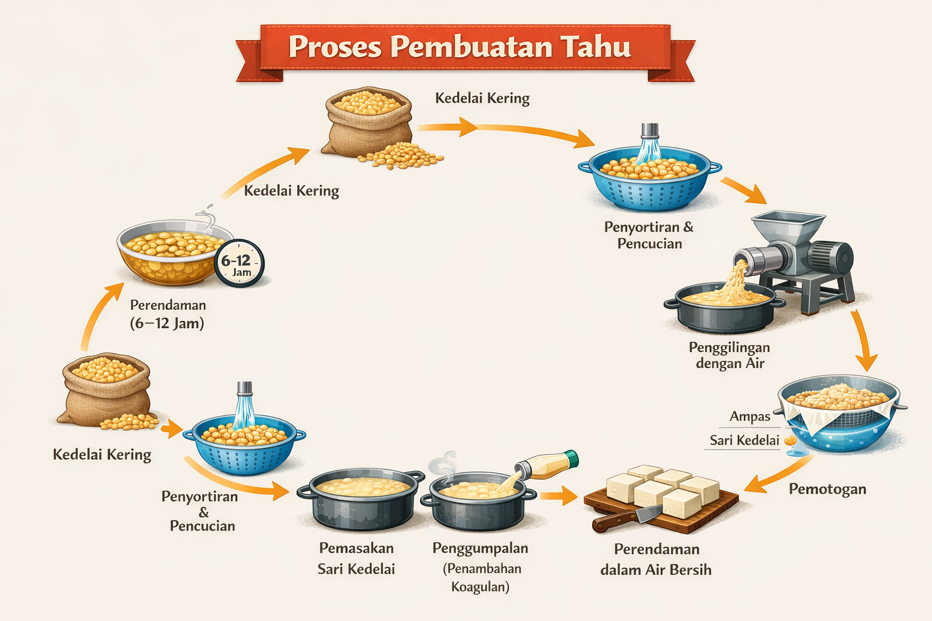
Gambar 1. Proses Pembuatan Tahu

SIMPULAN (Arial, 12pt, bold, 12pt Line Spacing before-after)
Simpulan merupakan ringkasan atas temuan penelitian dan implikasinya.
Saran diberikan untuk pengembangan dan penelitian lanjutan.
DAFTAR PUSTAKA (Arial, 12pt, bold, 12pt Line Spacing before-after)
Daftar pustaka merupakan bagian akhir dari makalah, ditulis dalam urutan alfabetis mengikuti APA Style (http://www.apastyle.org/). Susunannya memuat: nama penulis, tahun publikasi, judul paper atau textbook, nama jurnal atau penerbit, dan halaman. Berikut ini beberapa contoh cara penulisan daftar pustaka menurut APA Style. Disarankan menggunakan aplikasi Mendeley.

Reference List: Author/Authors

One Author
Suwardjono. (2018). Teori akuntansi: Perekayasaan pelaporan keuangan (Edisi 3). BPFE.

Two Authors
Dechow, P. M., & Skinner, D. J. (2000). Earnings management: Reconciling the views of accounting academics, practitioners, and regulators. Accounting Horizons, 14(2), 235–250.
Hery, & Widyawati, D. (2020). Akuntansi keuangan menengah. Grasindo.

Three to Seven Authors
Healy, P. M., Hutton, A. P., & Palepu, K. G. (1999). Stock performance and intermediation changes surrounding sustained increases in disclosure. Contemporary Accounting Research, 16(3), 485–520.
Weygandt, J. J., Kimmel, P. D., & Kieso, D. E. (2020). Financial accounting (11th ed.). Wiley.

More Than Seven Authors
Bushman, R. M., Piotroski, J. D., Smith, A. J., Chen, Q., Cheng, Q., Dhaliwal, D., . . . Zhang, X. (2004). Financial reporting incentives for conservative accounting: The influence of legal and political institutions. Journal of Accounting and Economics, 38(1–3), 1–37.

Organization as Author.
International Accounting Standards Board. (2018). Conceptual framework for financial reporting. IFRS Foundation.

Unknown Author
Dictionary of accounting terms (3rd ed.). (2015). McGraw-Hill Education.

Two or More Works by the Same Author
Watts, R. L. (2003). Conservatism in accounting: Part I—Explanations and implications. Accounting Horizons, 17(3), 207–221.
Watts, R. L. (2003). Conservatism in accounting: Part II—Evidence and research opportunities. Accounting Horizons, 17(4), 287–301.
Watts, R. L., & Zimmerman, J. L. (1986). Positive accounting theory. Prentice Hall..

Two or More Works by the Same Author in the Same Year
Scott, W. R. (2015a). Financial accounting theory (7th ed.). Pearson.
Scott, W. R. (2015b). The information perspective in financial accounting. Accounting Perspectives, 14(2), 79–101.

Introductions, Prefaces, Forewords, and Afterwords
Kieso, D. E., & Weygandt, J. J. (2020). Introduction. In D. E. Kieso, J. J. Weygandt, & T. D. Warfield (Eds.), Intermediate accounting (17th ed., pp. 1–25). Wiley.

Reference List: Articles in Periodicals

Article in Journal Paginated by Volume
Ball, R., & Brown, P. (1968). An empirical evaluation of accounting income numbers. Journal of Accounting Research, 6, 159–178.

Article in Journal Paginated by Issue
Jensen, M. C. (2001). Value maximization and the corporate objective function. Journal of Applied Corporate Finance, 14(3), 8–21.

Article in a Magazine
Byrnes, N. (2002, July 22). The new transparency in corporate reporting. BusinessWeek, 3790, 45–48.

Article in a Newspaper
Sorkin, A. R. (2020, March 15). Corporate accounting faces scrutiny amid crisis. The New York Times, B1–B2.

Reference List: Books

Edited Book, No Author
Graham, J. R., & Harvey, C. R. (Eds.). (2001). Corporate financial reporting practices. Elsevier.

Edited Book with an Author or Authors
Brigham, E. F. (2019). Financial management: Theory and practice (15th ed.). Cengage Learning.

A Translation
Pacioli, L. (1994). Summa de arithmetica (A. Clarke, Trans.). Oxford University Press. (Original work published 1494)

Edition Other Than the First
Harrison, W. T., Horngren, C. T., & Thomas, C. W. (2018). Financial accounting (11th ed.). Pearson.

Article or Chapter in an Edited Book
Healy, P. M., & Palepu, K. G. (2001). Information asymmetry, corporate disclosure, and capital markets. In J. Hand & B. Lev (Eds.), Intangible assets (pp. 33–60). Oxford University Press.

Reference List: Other Print Sources
Entry in an Encyclopedia
Bromwich, M. (2015). Management accounting. In C. Cooper (Ed.), Wiley encyclopedia of management (3rd ed., pp. 1–5). Wiley.

Dissertation Abstract
Sari, D. P. (2021). Corporate governance and earnings quality in ASEAN countries (Doctoral dissertation, Universitas Indonesia). Dissertation Abstracts International, 82, 1123A.

Government Document
Kementerian Keuangan Republik Indonesia. (2022). Laporan keuangan pemerintah pusat tahun 2021. Kementerian Keuangan RI.

Report from a Private Organization
Ikatan Akuntan Indonesia. (2022). Standar akuntansi keuangan efektif 2022. IAI.

Conference Proceedings
Siregar, S. V., & Utama, S. (Eds.). (2023). Proceedings of the International Conference on Accounting, Governance, and Sustainability (ICAGS 2023). Atlantis Press.
Hapsoro, D., & Rahman, A. (Eds.). (2022). Proceedings of the International Conference on Economics, Business, and Accounting Research (ICEBAR 2022). Springer. https://doi.org/10.1007/978-3-031-12345-6
Reference List: Electronic Sources (Web Publications)
Article From an Online Periodical with DOI Assigned
Francis, J., LaFond, R., Olsson, P., & Schipper, K. (2004). Costs of equity and earnings attributes. The Accounting Review, 79(4), 967–1010. https://doi.org/10.2308/accr.2004.79.4.967

Article From an Online Periodical with no DOI Assigned
Sari, D. P. (2020). The effect of audit committee effectiveness on earnings management. Jurnal Akuntansi Multiparadigma, 11(2), 215–230. https://jam.ub.ac.id/index.php/jam/article/view/2020

Wijayanti, R. (2019). Corporate governance and financial distress prediction. Jurnal Keuangan dan Perbankan, 23(3), 345–357. https://jurnal.unmer.ac.id/index.php/jkdp

Abstract
Pratama, A. (2022). The impact of ESG disclosure on firm value in ASEAN countries [Abstract]. Asian Journal of Accounting Research, 7(1), 88–89.

Newspaper Article
Sorkin, A. R. (2023, March 15). Regulators increase scrutiny on corporate financial reporting. The New York Times. https://www.nytimes.com

Electronic Books
Atrill, P., & McLaney, E. (2020). Management accounting for decision makers (9th ed.). Pearson. https://www.pearson.com
Harrison, W. T., Horngren, C. T., & Thomas, C. W. (2018). Financial accounting (11th ed.). Pearson. https://www.pearson.com

Chapter in Online Book
Healy, P. M., & Palepu, K. G. (2001). Information asymmetry, corporate disclosure, and capital markets. In J. Hand & B. Lev (Eds.), Intangible assets (pp. 33–60). Oxford University Press. https://doi.org/10.1093/019511099X.003.0002

Online Book Reviews
Zeff, S. A. (2021, April 10). Rethinking financial reporting standards [Review of the book The future of financial accounting]. Accounting Today. https://www.accountingtoday.com

Dissertation/Thesis from a Database
Putri, R. D. (2021). Corporate governance and earnings quality in emerging markets (Doctoral dissertation). ProQuest Dissertations Publishing. (UMI No. 1234567)

Online Encyclopedias and Dictionaries
Accounting conservatism. (n.d.). In Encyclopædia Britannica Online. https://www.britannica.com

Online Bibliographies and Annotated Bibliographies
International Federation of Accountants. (2022). Sustainability reporting: Annotated bibliography. https://www.ifac.org

Data Sets
World Bank. (2023). World development indicators [Data set]. https://data.worldbank.org

Graphic Data
International Monetary Fund. (2023). Global financial stability indicators [Data visualization]. https://www.imf.org

Online Interviews
Butler, C. (Interviewer) & Siregar, S. V. (Interviewee). (2022). The future of ESG reporting in Indonesia [Interview transcript]. https://www.accountingconference.org/interviews

Online Lecture Notes/Slides
Hapsoro, D. (2023). Earnings management and audit quality [PowerPoint slides]. https://www.university.ac.id/akuntansi

Nonperiodical Web Document / Report
International Federation of Accountants. (2023). Global accountancy profession report 2023. https://www.ifac.org

Computer Software
StataCorp. (2022). Stata statistical software: Release 17 [Computer software]. StataCorp LLC.
IBM Corp. (2021). IBM SPSS statistics for Windows (Version 27) [Computer software]. IBM Corp.

E-mail
E-mails are not included in the list of references, though you parenthetically cite them in your main text: (E. Robbins, personal communication, January 4, 2001).

Online Forum Posting
AkuntanPublik. (2023, July 10). Challenges in implementing PSAK 71 [Online forum post]. https://www.akuntansiforum.com

Blog Post
Deloitte Indonesia. (2023, May 2). ESG reporting trends in Southeast Asia [Blog post]. https://www2.deloitte.com

Wikipedia
Sustainability accounting. (n.d.). In Wikipedia. https://en.wikipedia.org/wiki/Sustainability_accounting

Podcast
International Federation of Accountants. (2023, June 5). The future of global audit standards [Audio podcast episode]. https://www.ifac.org

Video Podcasts
Scott, D. (Producer). (2007, January 5). The community college classroom [Episode 7]. Adventures in Education. Podcast retrieved from http://www.adveeducation.com
Reference List: Other Non-Print Sources
Interviews, Email, and Other Personal Communication
No personal communication is included in your reference list; instead, parenthetically cite the communicators name, the fact that it was personal communication, and the date of the communication in your main text only.

(E. Robbins, personal communication, January 4, 2001).
A. P. Smith also claimed that many of her students had difficulties with APA style (personal communication, November 3, 2002).

Motion Picture
Smith, J. D. (Producer), & Lee, R. (Director). (2022). The accounting scandal: Lessons from corporate collapse [Motion picture]. United States: Financial Insight Films.

A Motion Picture or Video Tape with International or National Availability
Smith, J. D. (Producer), & Smithee, A. F. (Director). (2001). Really big disaster movie [ Motion picture]. United States: Paramount Pictures.

A Motion Picture or Video Tape with Limited Availability
Harris, M. (Producer), & Turley, M. J. (Director). (2002). Writing labs: A history [Motion picture]. (Available from Purdue University Pictures, 500 Oval Drive, West Lafayette, IN 47907)

Television Broadcast or Series Episode
Producer, P. P. (Producer). (Date of broadcast or copyright). Title of broadcast [Television broadcast or Television series ]. City of origin: Studio or distributor.

Single Episode of a Television Series
Writer, W. W. (Writer), & Director, D. D. (Director). (Date of publication). Title of episode [Television series episode]. In P. Producer (Producer), Series title. City of origin: Studio or distributor.
Wendy, S. W. (Writer), & Martian, I. R. (Director). (1986). The rising angel and the falling ape [Television series episode]. In D. Dude (Producer), Creatures and monsters. Los Angeles, CA: Belarus Studios.

Television Broadcast
Important, I. M. (Producer). (2023, November 1). The future of public sector accounting [Television broadcast]. Jakarta: Metro TV.

A Television Series
Wendy, S. W. (Writer), & Hartono, B. (Director). (2021). Creative accounting practices exposed [Television series episode]. In D. Firmansyah (Producer), Corporate investigations. Jakarta: Business Channel Indonesia.

Music Recording
Rahman, A. (2022). Double-entry system explained [Recorded by Accounting Education Band]. On Learning accounting basics [MP3]. Jakarta: EduMusic Records.

