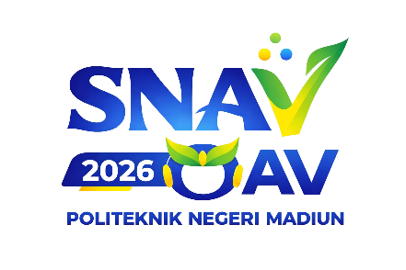
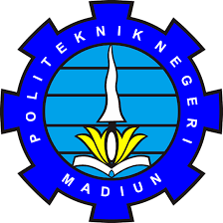
IX VOCATIONAL ACCOUNTING OLYMPIAD

OAV IX YEAR 2026
ACCOUNTING DEPARTMENT - STATE POLYTECHNIC OF MADIUN
Jl. West Ring Road, Madiun City 63133 Email: oav2026@pnm.ac.id

Format for Statement of Originality of Work (Journalistic Article)

STATEMENT LETTER

The undersigned below :
- Full Name : NPM/NIM:
As Group Leader
- Full Name : NPM/NIM:
As Member 1

Declaring that it is true that the journalistic article with the title,

“Journalistic Article Title”

This is an original work and has never been published or entered in any competition other than the 9th OAV National Journalism Article Competition in 2026 organized by the Madiun State Polytechnic. We are also willing to hand over ownership of the work to the 9th OAV Committee in 2026 to be reproduced and published in part or in whole.
Thus, we make this statement truthfully, and if it is proven that there are violations in it, then we are ready to be disqualified from this competition as a form of our responsibility.
City, Date-Month-Year Team Leader
Materai 10.000

Team Leader Name

