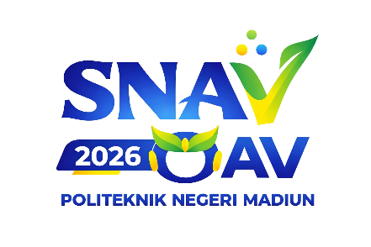
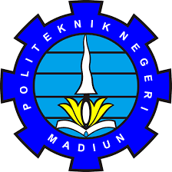
OLIMPIADE AKUNTANSI VOKASI IX

OAV IX TAHUN 2026
JURUSAN AKUNTANSI-POLITEKNIK NEGERI MADIUN
Jl. Ring Road Barat, Kota Madiun 63133 Email : oav2026@pnm.ac.id

Statement of Originality of Work (Poster)

DECLARATION LETTER

The undersigned below:
- Full Name : Student ID Number :
As Team Leader
- Full Name : Student ID Number :
As Member 1

Hereby declare that the Poster entitled,

“Poster Title”

is an original work and has never been published and/or entered in any competition outside the 9th National Poster Competition of OAV 2026, organized by Politeknik Negeri Madiun. We also agree to transfer ownership rights of the work to the OAV IX 2026 Committee for reproduction and publication, either partially or in full.
This declaration is made truthfully. If any violation is proven, we are willing to be disqualified from this competition as a form of our responsibility..
City, Date-Month-Year
Team Leader,
Materai 10.000

Name of Team Leader

